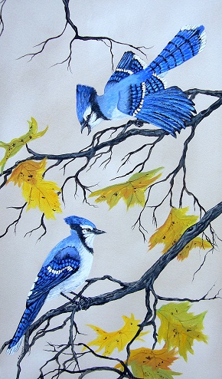 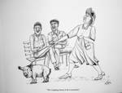

**ARTIST SHIRLEY KINNEBERG**

**ELK PONT, ALBERTA**



**“PRAIRIE PRIDES”** 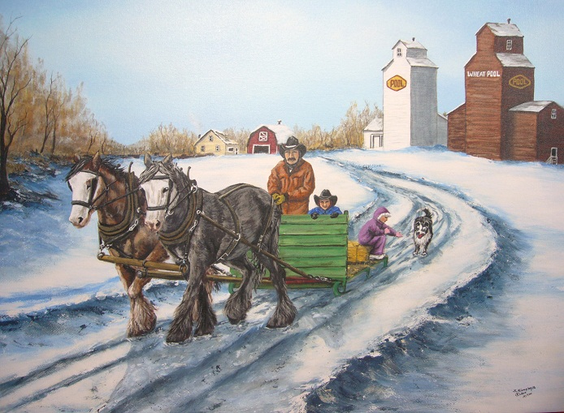

**22X30 Giclee Print - $125.00**

**Canvas Print - $195.00**

“BLUE JAY TALK” 15X24 “THE LAUGHING STOCK OF THE COUNTY”

Giclee Print - $85.00 Pencil Sketch - $45.00

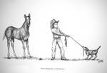 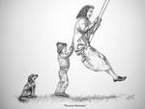

“ EVERY DISPUTE HAS A LITTLE HUMOR” “PRECIOUS MOMENTS”

Pencil Sketch - $45.00 Pencil Sketch - $45.00

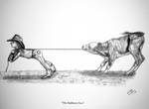

Shipping & Handling Cost is not included.

CONTACT: (780)724-3678

[SKINNEBERG@YAHOO.COM](mailto:SKINNEBERG@YAHOO.COM)

WEBSITE: WWW.SHIRLEYKINNEBER.COM

“THE STUBBORN TWO”

Pencil Sketch - $45.00

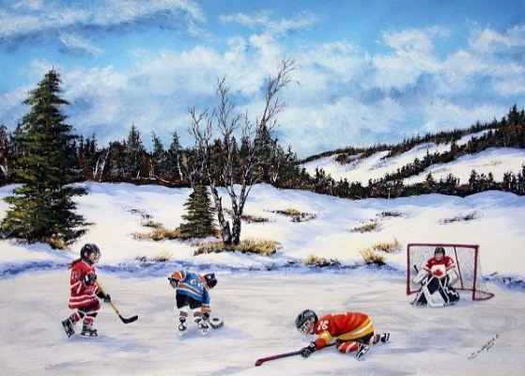 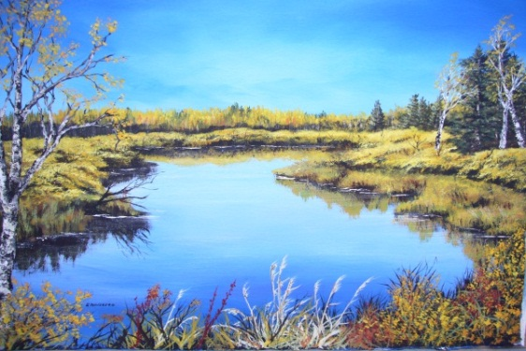

**LOCAL ELK POINT ARTIST SHIRLEY KINNEBERG**

**BORN IN THE HEART OF THE PRAIRIES NEAR MOOSEJAW, SASKATCHEWAN IS WHERE SHIRLEY FIRST GREW A DEVOTED INTEREST IN CREATING THE SCENERY AROUND HER. . SHIRLEY HAS BEEN IN THE ELK POINT AREA SINCE 1989 AND IS STILL THERE AS OF TODAY. HER LOVE FOR ART HAS PUT HER INTO MANY CLASSES WITH WELL KNOWN INTRUCTORS AS WELL AS BELONGING TO SEVERAL PAST AND PRESENT ART GROUPS THROUGHOUT LLOYDMINSTER AND EDMONTON . OILS, ACRYLICS, WATERCOLOUR AND PENCIL ARE THE CHOICE OF CONSTRUCTION FOR HER AND EXPERIMENTING IS A PASSION.**

**“AS AN ARTIST I LOVE TO PAINT WHATS AROUND ME. SIMPLE BRUSH STROKES WITH BOLD AND BRILLIANT COLOURS HAS ALWAYS BEEN THE CHOICE FOR ME. WHAT I SEE AND PORTRAY IN A REALISTIC MANNER MAY ELICIT A SPARK OF EMOTION OR MEMORY WITHIN ANOTHER . IF THIS SHOULD HAPPEN THEN I TRULY BELIEVE THAT THE ARTIST AND BEHOLDER HAVE SHARED A WONDERFUL EXPERIENCE TOGETHER.”**

COPYRIGHT IS SOUL OWNERSHIP TO THE ARTIST

“TEAM SPIRIT” 22X30 “AUTUMN SPLENDOR”18X26

Giclee Print - $85.00. Canvas Print - $165.00 Giclee Print - $85.00. Canvas Print - $165.00

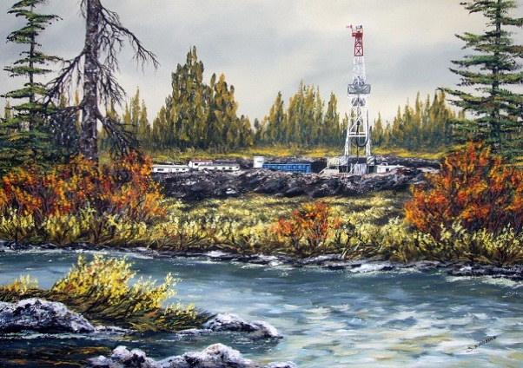 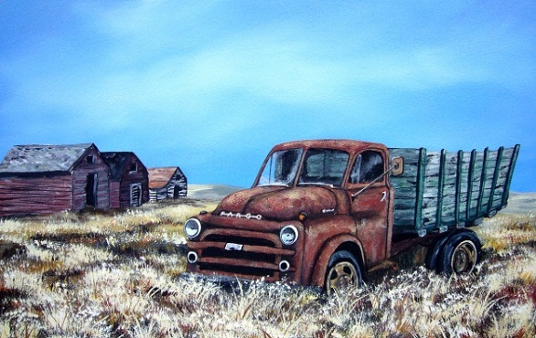

“SEASONABLE DRILLER” 26X32 “PRAIRIE FARGO” 14X22

Giclee Print - $125.00. Canvas Print - $195.00 Giclee Print - $75.00. Canvas Print - $155.00

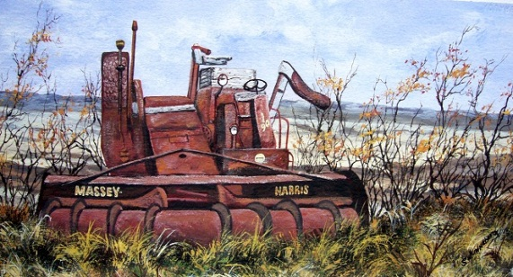 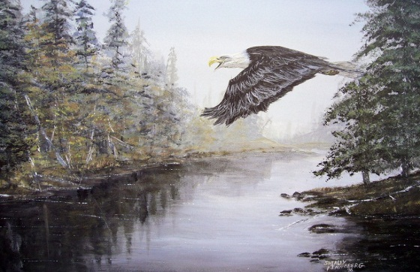

“PAST IT”S PRIME” 8X15 “INTRIGUING SHADOWS” 16X12

Giclee Print - $55.00 Laser Print - $65.00